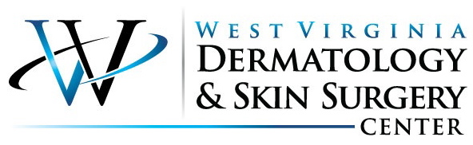

What is Mohs Micrographic Surgery?

Mohs Surgery was developed by Frederic E. Mohs, MD in the 1930’s. This procedure has continued to be perfected by physicians for more than half a century.

Mohs Surgery is a state of the art treatment for many types of skin cancers where the physician takes the role of surgeon, pathologist, and reconstructive surgeon.

Mohs surgery involves surgically removing skin cancers layer by layer. The physician then examines the tissue under a microscope and continues this process until only cancer free tissue remains. This technique is the most exact and precise method of tumor removal. It lessens the chance of cancer regrowth, leaves the surrounding healthy tissue unharmed and intact, and also allows for the least amount of scaring possible.
Mohs surgery is usually an outpatient procedure performed in a physician's office. Typically the surgery can be completed the same day, depending on the extent of the tumor and the amount or reconstruction necessary. Local anesthesia is administered around the area of the tumor so the patient is awake during the entire procedure.

Reconstruction
The best method of managing the wound resulting from surgery is determined after the cancer is completely removed. When the final defect is known, management is individualized to achieve the best results and to preserve function and maximize aesthetics. The Mohs surgeon is also trained in reconstructive procedures and often will perform the reconstructive procedure necessary to repair the wound.
What are the indications for Mohs Surgery?

Mohs surgery is most often used for treatment of the most common skin cancers, such as basal cell carcinoma and squamous cell carcinoma. This surgery has also been used for melanoma and other unusually skin cancers. Mohs surgery has proven to be successful for cancers that have a high risk of reoccurrence, have borders that are hard to define and cancers that are large or aggressive. Mohs surgery is most often performed in areas where you want to preserve the most possible healthy tissue and allow for the least amount of scaring. Most commonly the eyes, ears, nose, mouth, hairline, hands, feet, and genitals.

Effectiveness
Clinical studies have shown that Mohs micrographic surgery has a five-year cure rate up to 99 percent in the treatment of basal cell and squamous cell carcinomas.
Cost Effectiveness
Besides its high cure rate, Mohs surgery has shown to be cost effective. In a study of costs of various types of skin cancer removal, the Mohs process was found to be comparable when compared to the cost of other procedures, such as electrodesiccation and curettage, cryosurgery, excision or radiation therapy. Mohs surgery preserves the maximum amount of normal skin which results in smaller scars. Repairs are more often simple and involve fewer complicated reconstructive procedures.

The Mohs Surgeon
The highly-trained surgeons that perform Mohs surgery are specialists both in dermatology and pathology. With their extensive knowledge of the skin and unique pathological skills, they are able to remove only diseased tissue, preserving healthy tissue and minimizing the cosmetic impact of the surgery.
Dr. David Judy is a fellowship trained Mohs surgeon. He completed his Mohs Surgery and Procedural Dermatology fellowship at University of Massachusetts Medical School, a program recognized and approved by the American College of Mohs Surgery (ACMS) and The Accreditation Council for Graduate Medical Education (ACGME).
The Mohs College currently recognizes more than 50 training centers where qualified applicants receive comprehensive training in Mohs surgery. The minimum training period is one year during which the dermatologist acquires extensive experience in all aspects of Mohs surgery, pathology and training in reconstructive surgery.
**For more information about Mohs micrographic surgery visit the Mohs Surgery Patient Education website at http://www.skincancermohssurgery.org by the American College of Mohs Surgery. http://www.mohscollege.org/

